5. Data and Reporting Requirements:

5.1 Data Sources and Structures:
Historical records are showed and presented by the Marshfield Archive Application through a structured data storage system which consists of relational databases and digital image storage. This system also allows users to browse and retrieve archive documents such as school admission registers, historical booklets, and staff records.
The primary data sources used by the application are two SQLite databases which includes sources. dB and staff. db. An organised information is stored from these databases about the archived materials and staff records. The sources. dB database contains details about historical documents, such as the document title, category, date, and links to the related image files. This helps the system organise large numbers of scanned documents and quickly find them when users search for them.
The staff. dB database stores information about historical staff members associated with the archived institutions. This includes details such as staff names, roles, employment periods, and related historical references. The separation of staff data into a dedicated database improves maintainability and allows independent management of staff-related records.
Furthermore, the application relies on large collection of digitised images stored within the systems file structure. Scanned historical documents are represented by these images such as admission registers and booklet pages. Images are also organised into specific folders based on document type and their time. For instance, Admission Registers folder is the one containing the images of admission registers, which contains scanned pages of school records from the late 19th century.
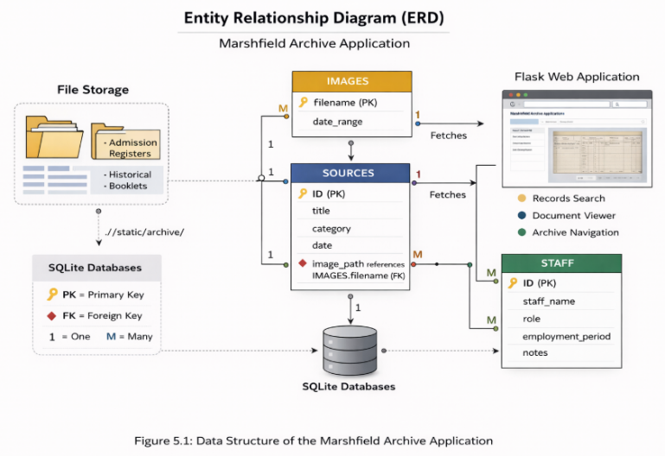
Each record in the database includes a reference to the related image files in these folders within the archive directories. When a user accesses a record on the website, the system retrieves the associated metadata from the database and displays the relevant scanned image. This method allows the application to efficiently organised the data from the database with unstructured archival content.
The overall data structure of the system ensures that historical information can be easily indexed, searched, and displayed through the web application. Figure 5.1 shows the basic structure of the data storage system used in the Marshfield Archive Application.

5.2 Reporting Needs:
The Marshfield archive application allows users to search for and view the historical records stored within the system. Rather than generating the traditional reports with statistics, the system only focuses on providing structured access to archival information through searchable records and visual document displays.
The system and users can retrieve the information about historical documents, staff members, and archived records through the web interface. The system dynamically generates result pages that displays relevant information from underlying databases. This page shows useful and important details from the database, such as document titles, historical descriptions, staff information, and links to the related scanned images stored in the archive folders.
Record retrieval and display are the primarily reporting functionalities which acts as an interactive report for users interested in historical data. When a document or category is selected by a user, the system shows a page with important details about the record and links it to scanned pages. This enables users to visually inspect historical documents while also accessing structured information about the records.
The system also supports browsing through collections of images such as admission registers and historical booklets. These image collections effectively work as visual reports of archival material, allowing users navigate through the historical records page by page, which
Access to this information is provided through the web interface of the application, making it way easier for users to access and view the archive. This ensures the data can be easily accessed and displayed in a user-friendly format. Rather than focusing on traditional numerical reporting it directly focusses on efficient retrieval, presentation, and navigation of historical archive data.
